

|  |
| --- |
| **Campus Quissamã**  **Curso Integrado Informática**  **Professor:** Renato  **Turma:** 2° ano informática  **Aluno:**João Felipe T. Paula  **Data:** 12/06/2019 |

**Arduino Semáforo**

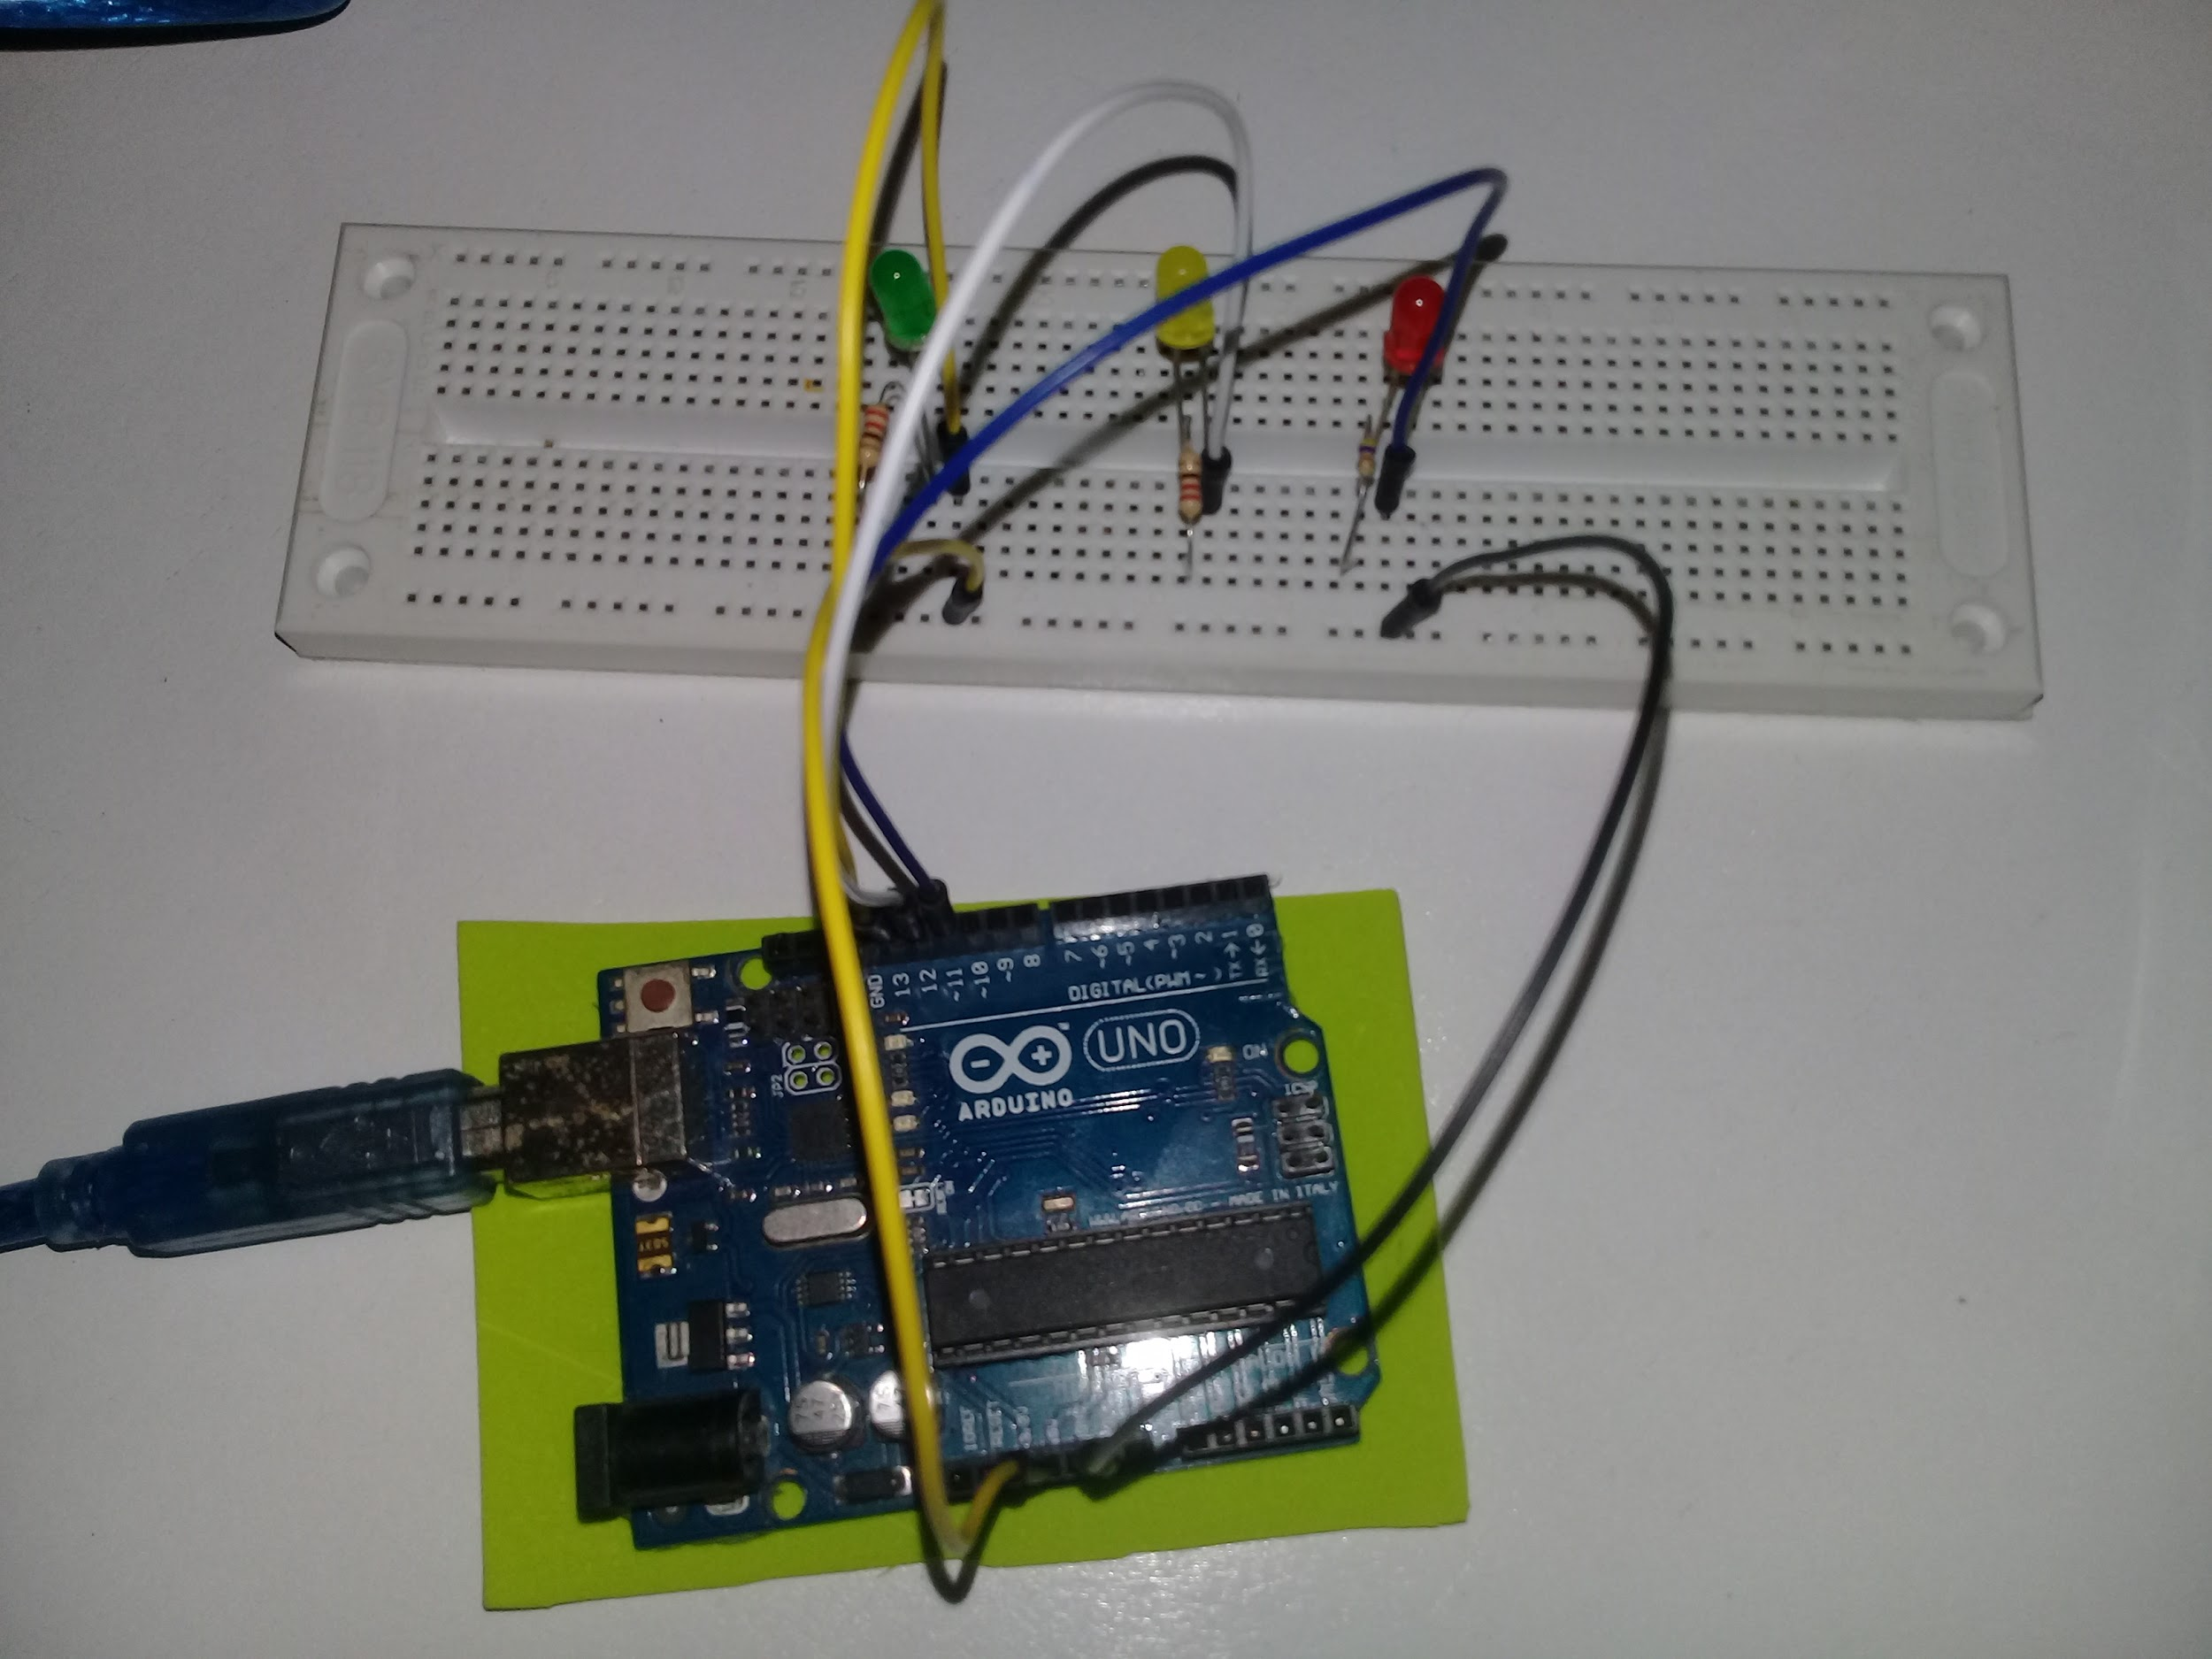

**Código**

int animationSpeed = 0;

void setup()

{

pinMode(13, OUTPUT);

pinMode(12, OUTPUT);

pinMode(11, OUTPUT);

}

void loop()

{

animationSpeed = 400;

digitalWrite(13, HIGH);

delay(animationSpeed);

digitalWrite(13, LOW);

delay(animationSpeed);

digitalWrite(12, HIGH);

delay(animationSpeed);

digitalWrite(12, LOW);

delay(animationSpeed);

digitalWrite(11, HIGH);

delay(animationSpeed);

digitalWrite(11, LOW);

delay(animationSpeed);

}

**Lista de Componentes**

Arduino

Cabo

5 Jumpers

3 LED (Verde,Amarelo,Vermelho)

3 Resistores (ohm 220)